Lesson 7 Demo 1: Create MKE Client Bundle

This section will guide you to:

* Create a client bundle in MKE

**Step 1:** Download the client certificates by creating a client bundle

* Sign in to **MKE** with your admin username and password
* Click on **My Profile** on the left-hand side panel

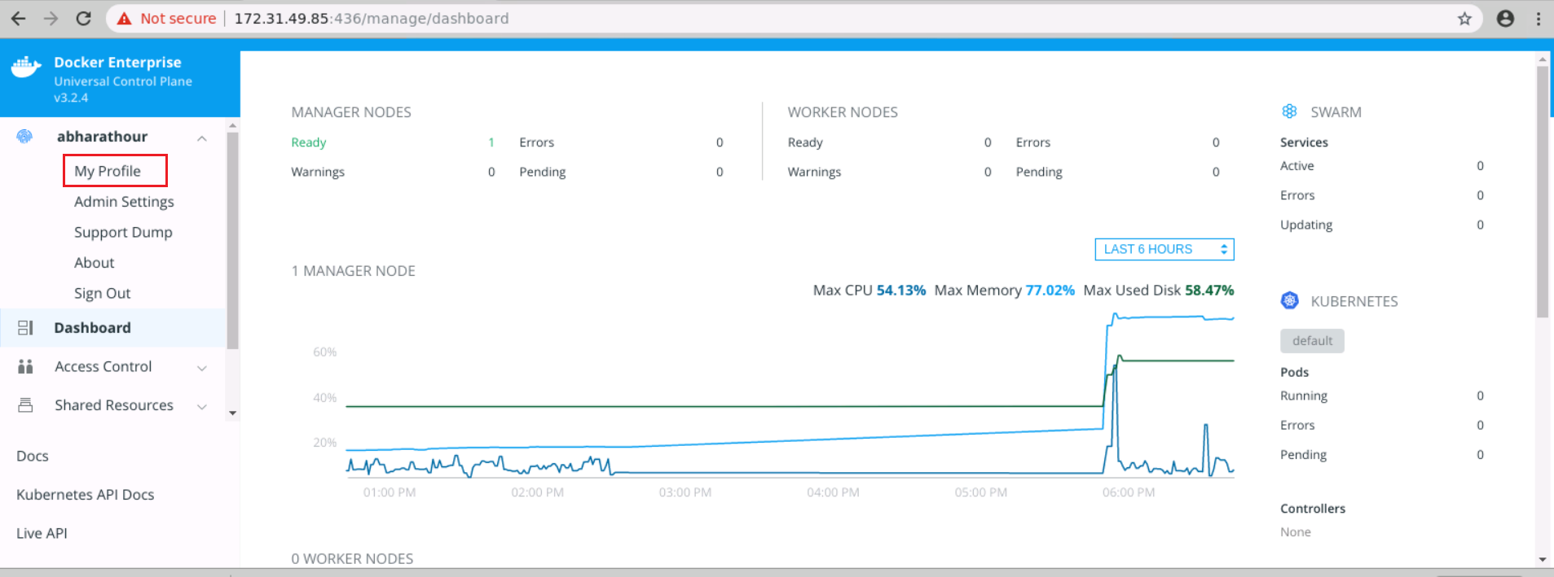

* Click on **New Client Bundle** dropdown and select **Generate Client Bundle** to download the certificate bundle

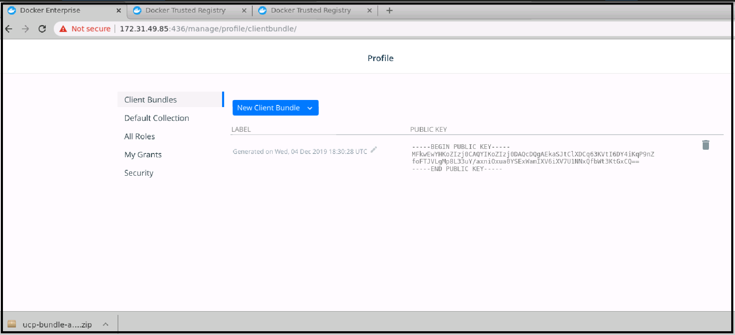

**Step 2:** Use the client certificate bundle to authenticate requests for running Docker commands on a MKE node

* Go to the directory where you have downloaded the ***.zip*** file, and use the following command to unzip it:

*cd /home/ubuntu/Downloads/*

*unzip ucp-bundle-abharathour.zip*

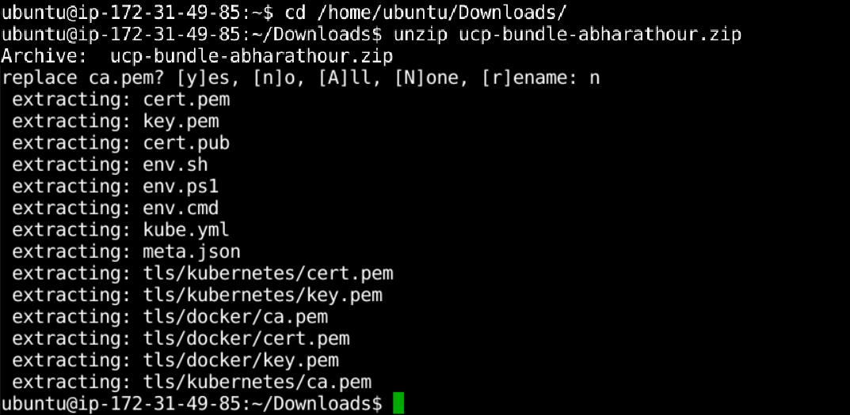

* Run the following command to start client certificates:

*eval $(<env.sh)*

* Use the Docker CLI with client certificates